- What Is Engineering? What Is Design? Worksheet
Design challenge: To design a picnic.
Brainstorm how you would plan and organize a picnic for friends.
Consider each of the steps in the design cycle and address each one.
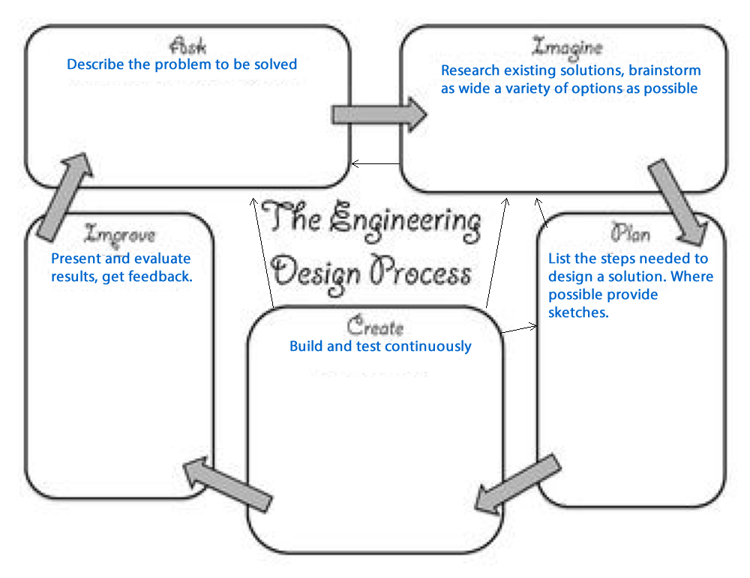
 | Plan | Create
What skills are needed?

What supplies are needed?

What are the costs in time and materials?

2. How do the designs compare? Worksheet
Compare the design of a picnic to the design of a computer game.
 | Plan | Create
What skills are needed?

What supplies are needed?

What are the costs in time and materials?

