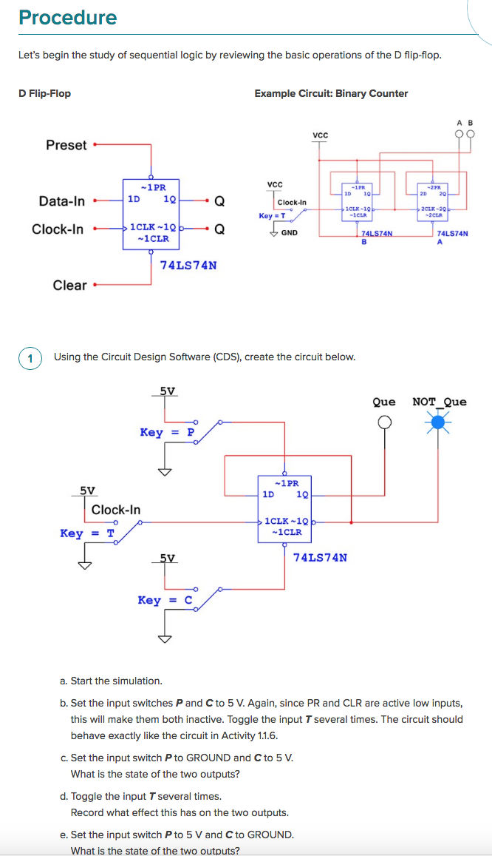

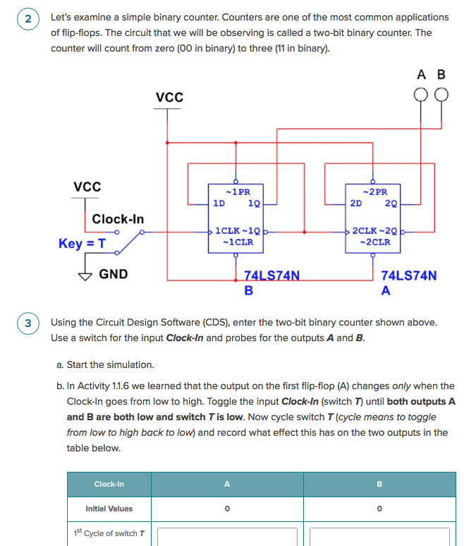

Continue for the next 4 cycles of T

|  |  |  |
| --- | --- | --- |
| 2nd cycle |  |  |
| 3rd cycle |  |  |
| 4th cycle |  |  |
| 5th cycle |  |  |

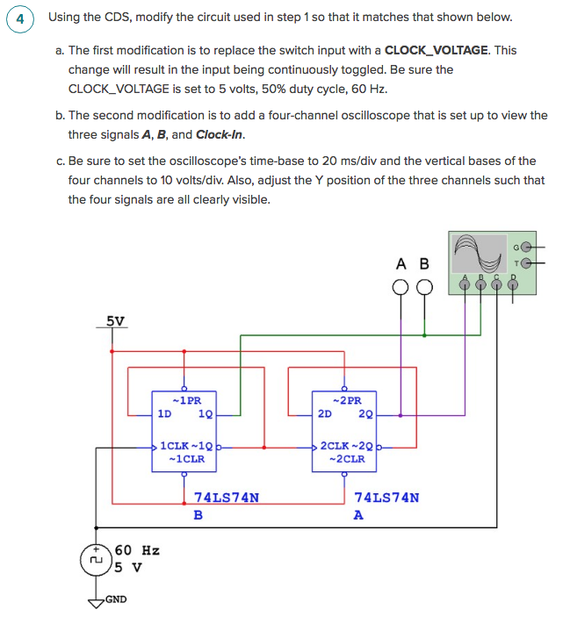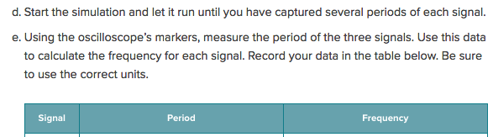

|  |  |  |
| --- | --- | --- |
| Clock |  |  |
| A |  |  |
| B |  |  |