Simple Machines - Notes

- All simple machines belong to one of two families
  - _______________
  - _______________
- The simplest machine is the ____________________
  - It is easier to do work if the ramp is ____________
  - What is the disadvantage to making the work easier? ___________
  - Label the 3 sides
__________________
__________________
__________________
  - What is the equation for the mechanical advantage?
___________________________________
- A screw is a type of ______________________________

LEVERS
- Describe and give an example of a first class lever
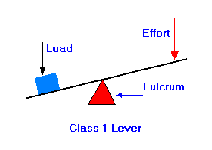
- Describe and give an example of a second class lever
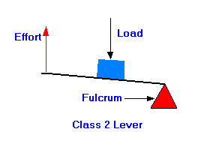
- Describe and give an example of a third class lever
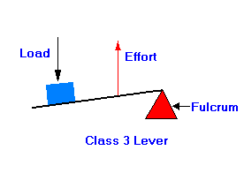

- For a 1st, 2nd, or 3rd class lever, the basic equation to calculate the Effort and Load is: _______________________________________
Where:
  - E stands for ____, the amount of weight pushing on a lever required to ___________ the load
  - L stands for ______, the amount of ____________ the lever is trying to move
  - ED stands for ________________, the distance between where the __________ is taking place and the _____________
  - LD stands for _____________, the distance between where the _______ is placed and the ______________
- Mechanical Advantage is achieved when a _________ force is used to move a ___________ force
- For a lever Mechanical Advantage is calculated using the equation:
  - MA stands for _____________________
  - R stands for ___________ or __________
  - E stands for _______________

WHEEL AND AXLE
- For a wheel and axle to be a simple machine there must be an ________, __________ and ____________.
- What is an example of a wheel and axle that IS a simple machine?
__________________________________
- Label the 2 important measurements and the equation for the mechanical advantage.
- 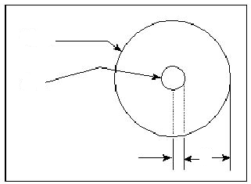
__________________
__________________
__________________
__________________
Simple Machines - Notes

THE PULLEY
A pulley makes it easier to move things by changing _____________ _____________________________
For each type of pulley, describe what it is and what it is good for
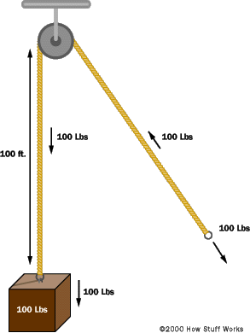 | 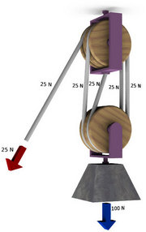 | 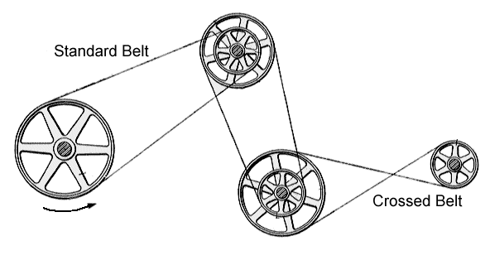
How do you calculate the mechanical advantage of a pulley?
_______________________________________________________

Play the simple machine robot game and answer the Reflections on the design of the software

1. What age group do you think this is suitable for?

2. Is this game easy to win?

3. Do you think students would really learn something by playing the game? Why or why not?

4. Would students want to play this game more than once? Why or why not?

5. Which of the 4 sections of this game do you think is the best? Why?

6. Which format do you think is better to develop this kind of game for: cell phone, tablet, or on the regular computer/laptop.?

7. Do you think it's possible that in the future students could interact with programs like this one and discover principles of science for themselves instead of hearing a lecture or a teacher explaining? Why or why not?

Get a screenshot of your final score and paste it into your document

